Creating a Vendor Guide

Cover Page –

Your Logo & Company Name
Your contact information –

Your Name
Buying Manager
Your email (try not to have a gmail – use yourname@yourcompany.com if possible)
Your website
Address
Telephone
Skype

Page 2 – Welcome & Intro to your company:

Welcome to the XYZ Company Vendor Guide. This resource will provide you with information on our vendor policies. If you have any specific questions – please direct them to your buyer. We look forward to building a great business relationship with you.

XYZ Company is a US based e-commerce company that sources private label products and sells directly to consumers via online channels as well as wholesale distribution networks in the American markets. XYZ Company was established in 2010 and is headquartered in Los Angeles, CA. Our mission is to provide the highest quality products with the best customer service to our customers making them life long buyers in our brand.

Our brands: We operate under a few different brands for all the categories we sell in.

(Include logos etc)

Health Now – Nutritional Supplements
Work it Out – Health and Fitness Products
Eye On You – Camera and Video Products
Kids R Us – Baby Products

Page 3 on: Any and all relevant information to your product & workflow

- Confidentiality
  - Any and all product inquiries or development requests are to be treated as confidential. Do not share our information or requests with anyone outside of our company.
  - A failure to maintain this confidentiality will result in immediate cancellation of existing Purchase Orders and future production.
- Samples
  - Sample Procedures are as follows:
    - Pre-Order Sample (before PO is issued)
    - PP Sample – this is the final approved sample before production can begin.
      - The production quality must be equal to the PP sample as well as all specs (measurements, weight, color etc)
      - Once PP sample is approved you may start production.
    - TOP Sample – (Top of Production) this sample is required from one of the first produced from the production line.
      - Please send TOP sample as soon as it is ready –
      - You cannot ship the production without TOP sample approval
    - Photo-shoot/Inspection Sample – we may require a photo-shoot sample or a sample for our inspection team – please provide this upon request.
  - Please Send all Samples to:
    - ETOEC Address (Chinese mailing address) or your address
    - Please include a tag that shows your style number, the person you are sending the sample to, and indicate what type of sample it is.

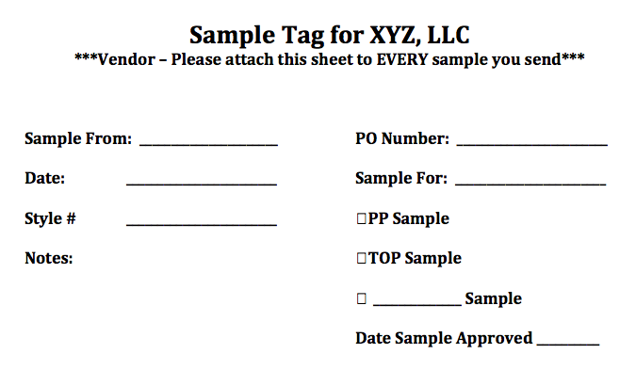

- Testing/Inspection
  - We often require testing of specific products
    - INCLUDE TESTING INFO HERE
  - Inspection
    - Please note we may/will send inspectors during the production process.
    - Our inspection company is: ABC Inspections
- Purchase Orders:
  - Purchase orders will have a PO number, please use this number as a reference going forward on all emails
  - POs will have a ship by date – please note that this date is FIRM – any changes in this date will require written approval and failure to ship on time will result in a chargeback of 3%.

- Payment Terms
  - Please note that our payment terms are as follows:
    - 30% Deposit at the time of the purchase order
    - 70% at the time of shipping
  - All transactions will be by T/T – please provide bank information to accountspayable@xyzcompany.com
  - Please note we will require confirmation by management of any changes to payment accounts and will require a letter from the company including a company chop to change the pay to account.

- Product Packaging
  - Any poly bags must be MINIMUM 1.5 mil, and be sealed closed.
  - Any poly bags with opening of 5” or larger require the following suffocation warning label in MINIMUM 10 PT font

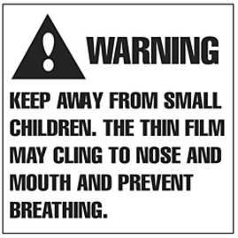
  - Please note all of our products have inserts – please ask your buyer for clarification on which inserts should be included.
  - If Color Boxes are used – please confirm whether the box also needs to be poly-bagged or sealed with a clear round sticker.
  - Please send 1% extra packaging with the shipment to provide extra packaging in case of damage during transit and products need to be re-packaged
  - All products will have a barcode – this will be provided to you by your buyer
- Returns/Damages/Defective products
  - Please note that XYZ Company has high standards when it comes to quality. We only allow a 1% defect/short rate. Anything above and beyond that will face a chargeback on the next invoice.
- Master Carton Requirements/Markings
  - Please use (5,7) layer boxes for the master carton
  - Case packs must not exceed 150 units per case pack
  - Case packs must not exceed 50 lbs
  - Master Cartons must not exceed 25 inches on any side unless the product is oversized. IF it is oversized, please contact your buyer for further information.
  - Carton Marking Must include:
    - Brand Name
    - Product Name (use a descriptive name if you have multiple similar items) i.e. single blue spatulas, double purple spatulas
    - PO#
    - ASN# (if any)
    - Net weight, Gross Weight
    - Qty in case
    - Made in China (COO – country of origin)
    - Carton Measurements
    - Color/Size (variation if any)
    - Style #
    - Carton x of y
- Legal Requirements
  - All products must be marked with COO (Country of Origin) they must bear the mark “Made in China” or whatever country of origin.
  - Law Labels
  - FDA Requirements
  - UL Certification

- Freight Forwarding
  - Please contact Name at Freighforwarding Company to arrange shipments
  - Our Customs Bond # __________
  - All products will ship to: Address (unless otherwise)
    - USA Warehouse
    - UK Warehouse
    - Canada Warehouse

I have read and accepted the terms of this agreement.

Company Name:
Name:
Position:

Date:

